Chapter 9: Pythagoras' theorem and trigonometry

Worksheet A

1 Find the length of the hypotenuse (x) in these triangles, correct to one decimal place
where necessary.

a b
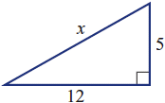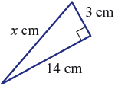

________________________________ ________________________________

________________________________ ________________________________

________________________________ ________________________________

________________________________ ________________________________

2 Determine the value of x in these triangles, to one decimal place where necessary.

a b
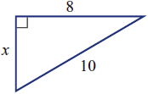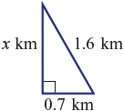

________________________________ ________________________________

________________________________ ________________________________

________________________________ ________________________________

________________________________ ________________________________

3 Two poles are 4.8 m apart. A wire links the tops of the two poles. Find the length of the
wire if the poles are 5.6 m and 9.2 m in height.
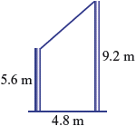
______________________________________

______________________________________

______________________________________

______________________________________

______________________________________

4 Two hikers leave their camp (C) at the same time. One walks due west for 1.7 km;
the other walks due south for 3.8 km. How far apart are the two hikers at this point,
correct to one decimal place?

______________________________________________________________________

______________________________________________________________________

______________________________________________________________________

______________________________________________________________________

______________________________________________________________________

5 Find the distance from one corner of this rectangular prism to the opposite corner,
correct to two decimal places.

______________________________________









